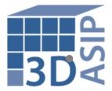

**3D ASIP – 12 Years and Going Strong**

Research Triangle Park, NC - August 7, 2015 **-** The 12th annual [***3D Architectures for Semiconductor Integration and Packaging Conference,*** or ***3D ASIP*** as it has come to be known,](http://www.3dasip.org/) will be heldDecember 15-17, 2015, at the Sofitel San Francisco Bay Hotel in Redwood City, California. It is the longest running conference on 2.5 / 3DIC focused on commercialization and infrastructure.

The conference general chair and program coordinator will be Dr. Philip Garrou, Microelectronics Consultants of NC, who has served as technical co-chair for many years. Professor Mitsumasa Koyanagi, Tohoku University, and Dr. Rama Alapati, Director of Packaging Product Management, GLOBALFOUNDRIES, are this year’s technical co-chairs.

First day tutorials will be headed up by Matt Lueck, RTI International and consultant Herb Reiter, eda2asic. Mr. Lueck will lead a group of presenters from CEA-Leti, HD Micro, Dow, TOK, Brewer Science, SUSS MicroTec, and TOK in discussions about the current state of the art in bonding and debonding technologies. Mr. Reiter will lead an interposer design tutorial including presentations from Mentor Graphics, Cadence, Ansys, and eSilicon, among others.

This year 3D ASIP will honor two trailblazers in 3DIC. Dr. Peter Ramm, Fraunhofer EMFT and Professor Mitsumasa Koyanagi, Tohoku University will be honored for their early pioneering work in the 1990s that set the stage for what we know today as 3DIC, including TSV, thinning, and bonding. Following the award ceremony, each recipient will deliver a short presentation on his group’s early work in 3DIC.

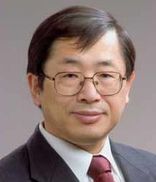 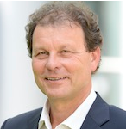

Mitsumasa Koyanagi Peter Ramm

Plenary presentations will be delivered by Brandon Prior, Prismark, who will discuss the status of 2.5/3D and other high density technologies; Rozalia Beica, Yole Développement, who will compare and contrast the new 3D memory architectures; and Beth Keser, Qualcomm, who will review fan out WLP technology as an option to 2.5D.

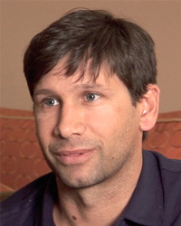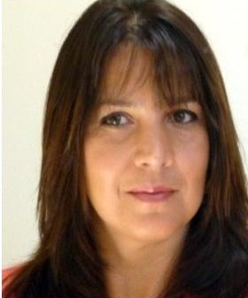 

Brandon Prior Rozalia Beica Beth Keser

The nine sessions will include topics such as: *Memory Stacks become Reality, Products and Production in the 2.5/3D Infrastructure, Processing, Equipment, and Metrology, High Density Packaging without TSV, and Heterogeneous Integration and Image Sensing*.

Key presentations will include Hynix, Micron, Tezzaron, and Toshiba discussing their new 3D stacked memory products; Xilinx/SPIL, Amkor, and TSMC discussing their non-TSV high density solutions; and AMD discussing the commercialization of Fiji graphics modules with HBM memory stacks. Dan Green of DARPA will discuss DARPA’s DAHI heterogeneous integration 3D platform; and Sony will discuss their new stacked image sensor technology.

[Registration](http://3dasip.org/proceedings/) is open. For more information on the conference agenda, speakers, and sponsorship / exhibit opportunities, visit the conference website at [www.3dasip.org](http://www.3dasip.org).